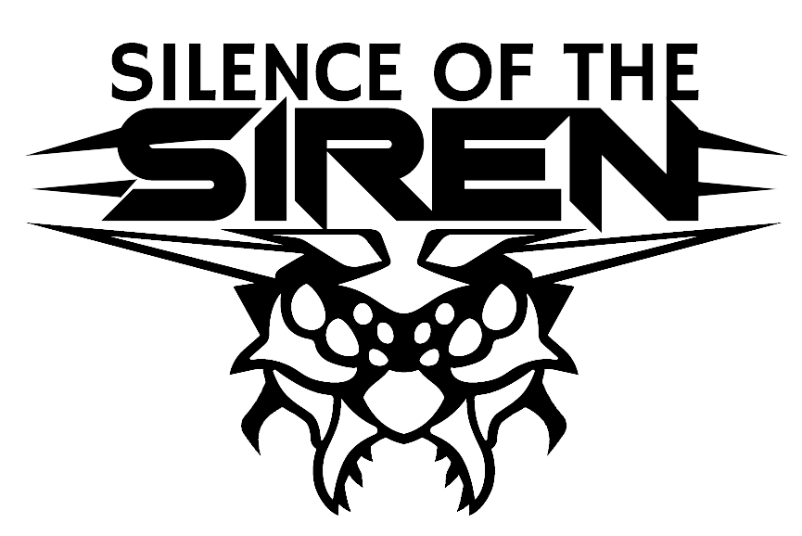

Oxymoron Games, the creators of Project Hospital, are happy to announce their next game which has been in development for several years. Silence of the Siren is a turn-based strategy game in which you will be thrown into a chaotic universe where several space-faring civilizations are fighting over control of a distant star system and trying to discover its dark history. Explore different planets, gather resources to expand your bases, raise an army and defeat your opponents!

New war in an ancient universe
The Siren star system, birthplace of a galactic alliance, and homeworld of lost Primals civilization, has been cut from the rest of the galaxy. As a result, the carefully built alliance split into bickering factions and secluded colonies. These days, hardly anyone pays attention to the ruins scattered all over the few habitable planets of a freshly isolated system. The deeper you venture into the uncharted regions, the stronger the feeling of endangerment grows. There is something else. An entity, a shade, an echo of whispers from below.

Build and discover
Explore what's left on the planets and secure important resources. Use them to upgrade your bases with advanced technology and to hire massive armies. Play as several different factions, recruit skilled commanders, teach them new skills and lead them into battle. Overcome obstacles on the map to gather powerful equipment and ancient artifacts.

Dominate the battlefield
Encounter a wide range of enemies in turn-based combat, use your tactical thinking to gain advantage on the battlefield. Learn the unique moves of your units, deploy your commander's special abilities and outsmart even much stronger opponents.

Key elements
- Explore a rich sci-fi world and discover secrets of a lost civilization
- Collect powerful artifacts, secure important resources, upgrade your bases and hire the strongest units
- Level-up your commanders and crush your opponents in exciting turn-based battles
- Take control over several different species and factions
- Old-school strategy game with modern controls and intuitive UI

About Oxymoron Games
Oxymoron Games is an indie game studio based in Prague which created the successful strategy/sim Project Hospital. With veterans who worked on games ranging from Mafia II and III, Quantum Break, Total War: Three Kingdoms to Top Spin 4, Silent Hill: Downpour or Euro Truck Simulator 2, the studio has been growing and is now fully focusing on Silence of the Siren.

